
Patuakhali Science and Technology University

Faculty of Computer Science and Engineering

CCE 310: Software Development Project-I

Sessional Project Proposal

Project Title: Reuse Hub
Submission Date: Sat 19, July 2025

Submitted from, | Submitted to,
Prosenjit Mondol  ID: 2102049,  Reg: 10176,  Semester: 5  (Level-3, Semester-1) | - Prof. Dr. Md Samsuzzaman  Professor,  Department of Computer and Communication Engi- neering,  Patuakhali Science and Technology University.  - Arpita Howlader  Assistant Professor,  Department of Computer and Communication Engi- neering,  Patuakhali Science and Technology University.

Contents
- Abstract 3
- Objectives 3
- Problem Statement 3
- Related Work 3
- Scope 4
- Methodology 4
  - Technology Stack 4
  - Design Principles 4
- Visual Models 5
  - Flow Chart Diagram 5
  - ERD (Entry Relationship Diagram) 6
  - Timeline (Gantt Chart) 6
  - UI Mockups 7
- Limitations 9
- Result 9
Bibliography 9

Reuse Hub 

Abstract
Reuse Hub is a cross-platform application designed to promote sustainable living through community-driven item reuse. It connects donors and seekers, enabling free exchange of usable goods with an intuitive and secure interface. Built using Flutter and powered by Supabase, the app ensures real-time interactions and platform independence. Key features include item listings, request handling, messaging, and role-based access. Reuse Hub aims to reduce waste while fostering a culture of sharing and environmental responsibility.

Objectives
- To develop a unified, cross-platform platform for donating and requesting reusable household items.
- Implement secure login and user roles.
- Enable item listing, browsing, and filtering.
- Support direct requests and real-time messaging.
- Ensure responsive design across mobile and web

Problem Statement
Existing item reuse and donation platforms are often fragmented, platform-dependent, or limited in functionality. Many rely on outdated interfaces, lack mobile responsiveness, or operate through third-party social groups with no automation. Key features such as real-time messaging, role-based access, and location-aware discovery are often missing. There is a clear need for a modern, cross-platform solution that streamlines item reuse while promoting sustainability and user convenience.

Related Work
- [1] OLIO- A widely-used food and item sharing app. However, it is heavily localized and lacks full-featured support for non-food items.
- [2] Freecycle - A nonprofit global network for item reuse, but suffers from outdated UI, limited mobile experience, and lacks in-app messaging.
- [3] Letgo(Now OLX) - Supported local item sharing. Shifted focus to resale, reducing emphasis on community reuse.
- [4] Trash Nothing -Focused purely on free giving, but lacks a modern UI, role-based access.
- [5] Facebook Marketplace -Highly popular and lacks filters for free.
- [6] Buy Nothing Project – A community-driven model restricted to Facebook Groups, lacking automated request handling and notifications.
- [7] Too Good to Go – Focuses only on surplus food donations, with no support.

Scope
Reuse Hub is a cross-platform application built using Flutter, designed to facilitate the reuse and redistribution of pre-owned items within communities. The platform will enable users to donate or request items through a streamlined, user-friendly interface. Core functionalities include user authentication, item listings, request handling, messaging, and category-based browsing. The application ensures accessibility across Android, iOS, and web platforms.
In future iterations, Reuse Hub can be expanded to support location-based recommendations, donation history tracking, user reviews, item delivery logistics, and integration with local NGOs or sustainability programs.

Methodology

Technology Stack
The development of Reuse Hub will follow an agile methodology, allowing for iterative improvements and user feedback. Our technology stack will include,

Frontend | Flutter[8] (Dart)
Backend | Supabase
UI/ UX Design | Figma
Database | PostgreSQL
Authentication | JWT or OAuth2
Hosting (web app) | Vercel or Netlify
CI/CD | GitHub Actions, Docker (optional)
Table 1: Technology Stack for Reuse Hub

Design Principles
The design of Reuse Hub will adhere to the following principles,

Material Design | Adopts Google’s Material Design guidelines to ensure a consistent and modern UI/UX across Android devices.
Responsive Design | Guarantees seamless performance across various screen sizes and orientations, including desktop, tablet, and mobile views.
User-Centric Design | Prioritizes user experience with intuitive navigation, minimal steps, and clear visual elements for both donors and receivers.
Cross-Platform | Ensures consistent design and functionality across Android, iOS, and web platforms using a unified development approach.
Documentation | Provides thorough documentation for developers (e.g., API docs) and end-users (e.g., help guides, FAQs).
Table 2: Design Principles for Reuse Hub

Visual Models

Flow Chart Diagram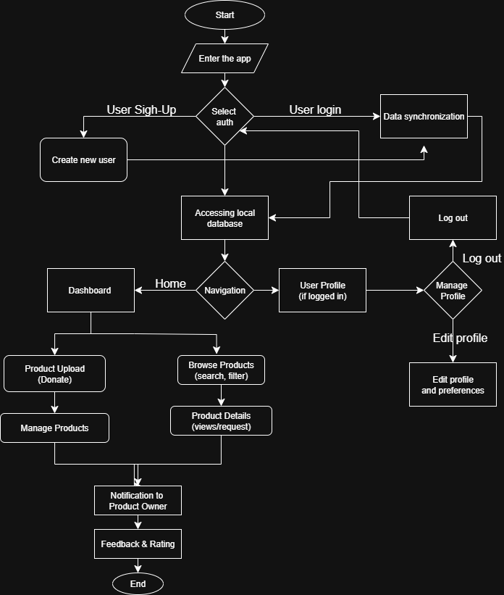

Figure 1: Flow Chart of Reuse Hub Architecture

Figure 1 illustrates the high-level user interaction flow of Reuse Hub, showcasing how various components such as item listing, request handling, and user roles (Donor and Seeker) operate within the app. The diagram primarily focuses on the frontend-driven flow, from authentication to donation completion.

ERD (Entry Relationship Diagram)
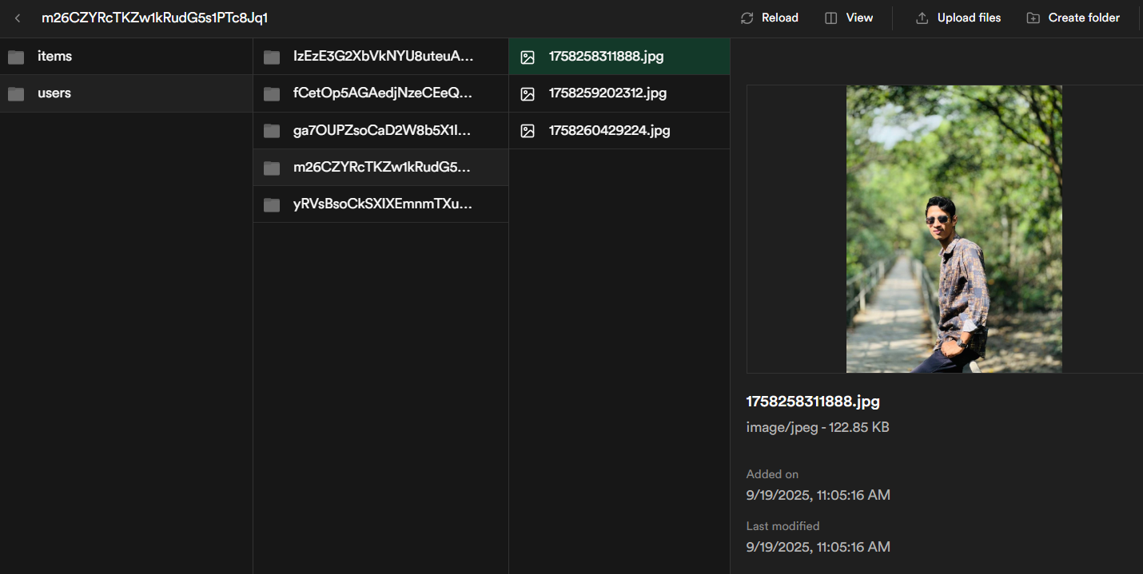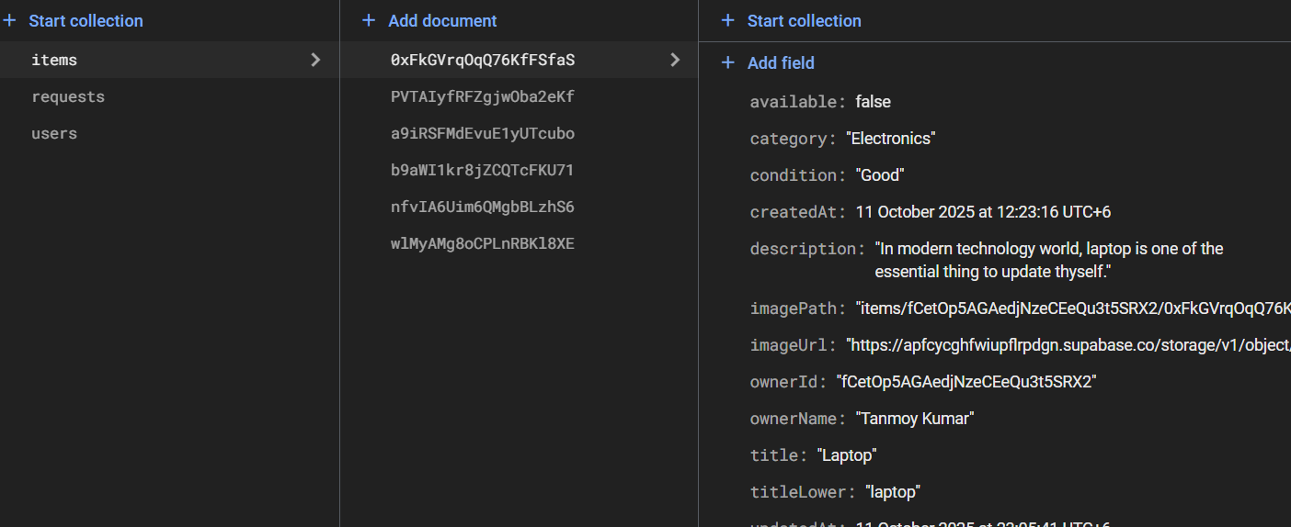
Figure 2: Entity Relationship Diagram of Reuse Hub

Timeline (Gantt Chart)
The base timeline for the development of Reuse Hub is as follows,

Task | Week  1-4 | Week  5-7 | Week  8-9 | Week  10-11 | Week  12 | Week  14 | Week  15 | Week  16
Requirements &  UI Wireframing | ✓ |  | ✓
Authentication  + DB |  | ✓ | ✓
Item Listing & Upload Module |  |  | ✓ | ✓
Nearby Item Discovery |  |  |  | ✓
Request & Donation Management |  |  | ✓ | ✓ | ✓
Chat & Notification System |  |  |  |  |  | ✓
UI Polish + Accessibility |  |  |  |  |  | ✓ | ✓
Final Testing &  Deployment |  |  |  |  |  |  |  | ✓
Table 3: Development Timeline of Reuse Hub

UI Mockups
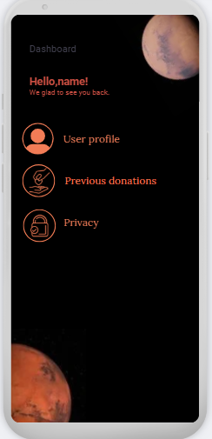

Figure 3: Dashboard

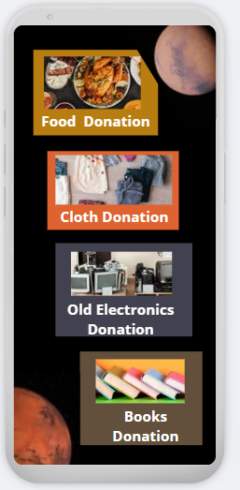
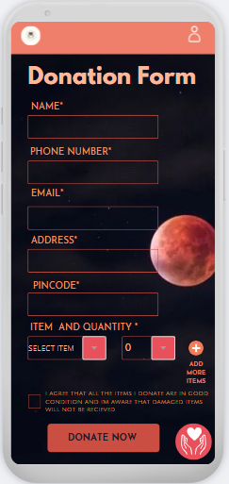

Figure 4: Donation type and Donation Form UI concept
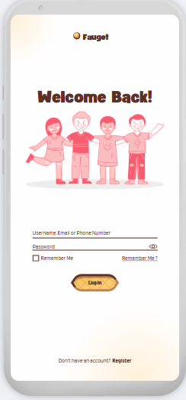
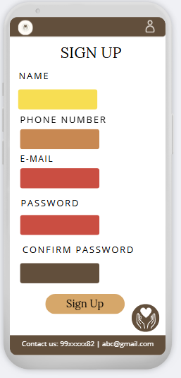

Figure 5: Login and Sign-Up page’s UI concept

Limitations
- User base growth is dependent on community awareness and participation, which may be slow initially.
- The app relies on accurate location data; privacy concerns or GPS inaccuracies may affect user experience.
- Lack of a formal verification system for item quality or donor credibility.

Result

The expected outcome of Reuse Hub is a fully functional, cross-platform application that enables users to donate and collect reusable household items efficiently.

📚 Bibliography
[1] Flutter, “Flutter Documentation,” [Online]. Available: https://flutter.dev/docs. [Accessed: Jul. 18, 2025].
[2] Firebase, “Firebase Documentation,” [Online]. Available: https://firebase.google.com/docs. [Accessed: Jul. 18, 2025].
[3] Google, “Google Maps Platform,” [Online]. Available: https://developers.google.com/maps/documentation. [Accessed: Jul. 18, 2025].
[4] United Nations, “Sustainable Consumption and Production,” United Nations Sustainable Development Goals, [Online]. Available: https://www.un.org/sustainabledevelopment/sustainable-consumption-production/. [Accessed: Jul. 18, 2025].
[5] Ellen MacArthur Foundation, “What is a Circular Economy?” [Online]. Available: https://ellenmacarthurfoundation.org/topics/circular-economy-introduction/overview. [Accessed: Jul. 18, 2025].
[6] OLX, “Online Marketplace Bangladesh,” [Online]. Available: https://www.olx.com/. [Accessed: Jul. 18, 2025].
[7] Donate Kart, “Donate Essentials,” [Online]. Available: https://www.donatekart.com/. [Accessed: Jul. 18, 2025].
[8] J. Smith, “Designing Cross-Platform Mobile Apps with Flutter,” *International Journal of Software Engineering*, vol. 12, no. 3, pp. 45–56, Mar. 2024.
[9] L. Chen and M. Gupta, “Community-Driven Sustainability Initiatives: A Case Study,” *Journal of Environmental Studies*, vol. 10, no. 2, pp. 120–130, Feb. 2023.

THE END

Weekly Report

No | Date | Objective | Remark

01

02

03

04

05

06

07

08

09

10

11

12

13

14

15

16

17

18

19

20

